**Challenge 1**

**BLink-it**

In this we use digital I/O pins to give the inputs to leds. And we write the code in such a way that the leds were blinking one after another with delay of 1 second.

Here resistors are connected to led to control the input voltage.

Here we used 13,12,11,10,9,8,7 pins for giving the input.

digitalWrite(Input_pin,HIGH) means the voltage is set to 5V

digitalWrite(Input_pin,LOW) means the voltage is set to 0V

delay(1000) means there is a delay of 1000milliseconds between two instructions

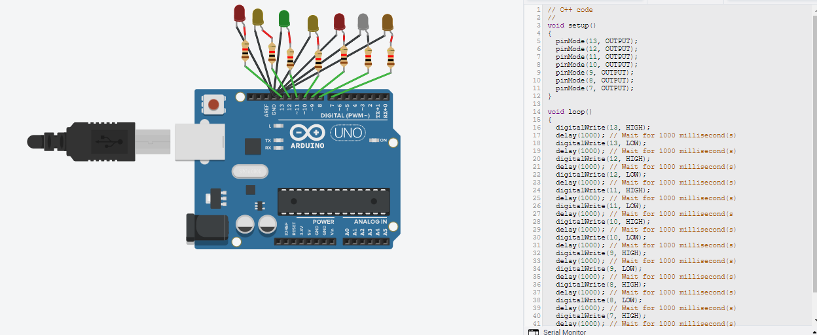

<https://www.tinkercad.com/things/cLyMao8JVAN>

**Challenge 2**

a)

Here we have to make the given circuit using breadboard and ICs.

We use power supply to give the input A,B,C and D to the ICs. The connections were made using ICs.

The output of the given circuit can be seen in led. If led is on it means output is high(or 1) and if led is off output is low(or).

IC 7408(AND gate), IC 7404(NOT gate) and IC 7432(OR gate) are used. The connections are made using connecting wires.

When the input A=1,B=1,C=1,D=0, the led is off which means output is low (or 0).

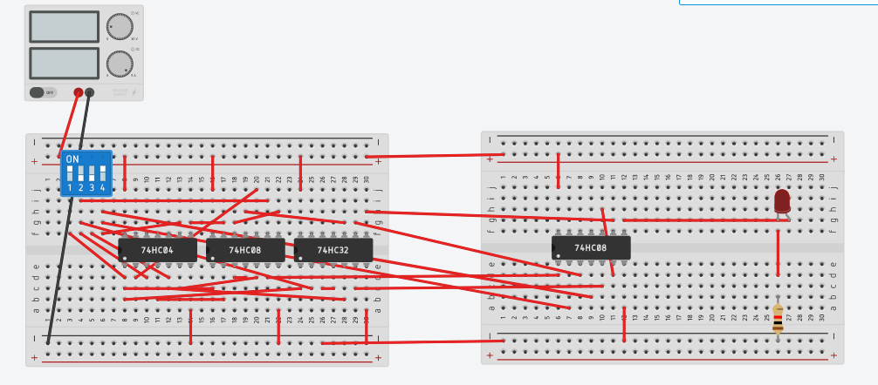

https://www.tinkercad.com/things/2w5oAJi46Km